**DAILY ONLINE ACTIVITIES SUMMARY**

|  |  |  |  |  |  |  |  |  |
| --- | --- | --- | --- | --- | --- | --- | --- | --- |
| **Date:** | **26/06/2020** | | | | | **Name:** | **Shwetha** | |
| **Sem & Sec** | **8th B** | | | | | **USN:** | **4AL16CS101** | |
| **Online Test Summary** | | | | | | | | |
| **Subject** | | **-** | | | | | | |
| **Max. Marks** | | **-** | | **Score** | | | **-** | |
| **Certification Course Summary** | | | | | | | | |
| **Course** | **Machine learning terminology and process** | | | | | | | |
| **Certificate Provider** | | | **AWS** | | **Duration** | | | **1hr** |
| **Coding Challenges** | | | | | | | | |
| **Problem Statement:**  **Java program to calculate CGPA percentage.** | | | | | | | | |
| **Status: Solved**  **Solution link: https://github.com/alvas-education-foundation/Shwetha-** | | | | | | | | |
| **Uploaded the report in Github** | | | | | **Yes** | | | |
| **If yes Repository name** | | | | | **Shwetha-** | | | |
| **Uploaded the report in slack** | | | | | **Yes** | | | |

Certification Course Details:

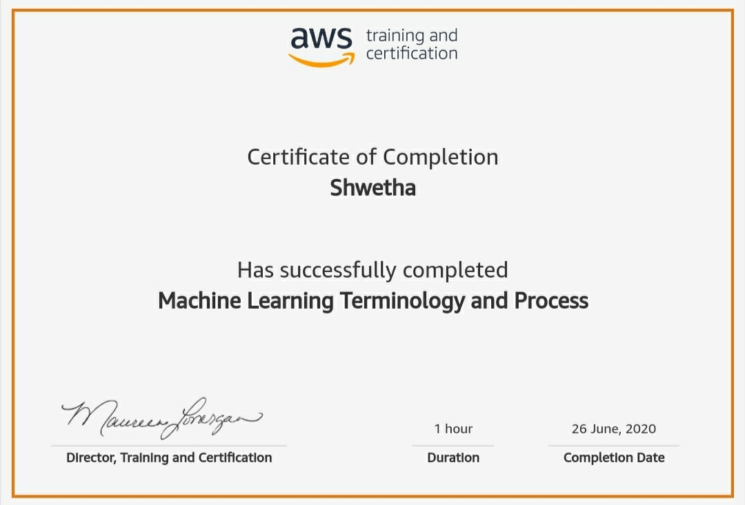

*Coding Challenges Details:*

public class CGPAProgram

{

public static void main (String args[])

{

double English, Hindi, Maths, Science, SocialStudy, CGPA, CGPAper ;

English = 9.1;

Hindi = 8.5;

Maths = 9.5;

Science =9.6;

SocialStudy = 8.6;

CGPA = (9.1+8.5+9.5+9.6+8.6)/(5.0);

CGPAper = (float)(9.5 * (CGPA));

System.out.println(" CGPA Percentage is: "+CGPAper);

}

}